Final aug_probas: nfrac=0.015->1.0, nfrac=0.052->1.0, nfrac=0.1->1.0, nfrac=0.2->0.8, nfrac=0.3->0.6

Potes

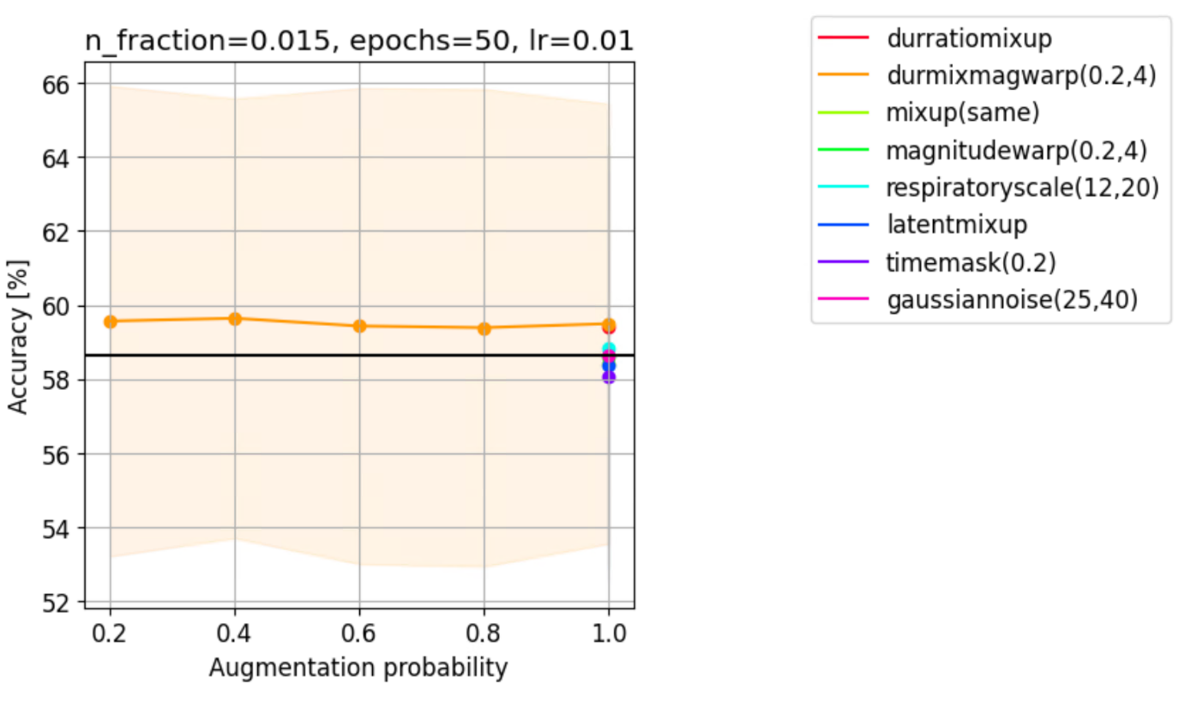

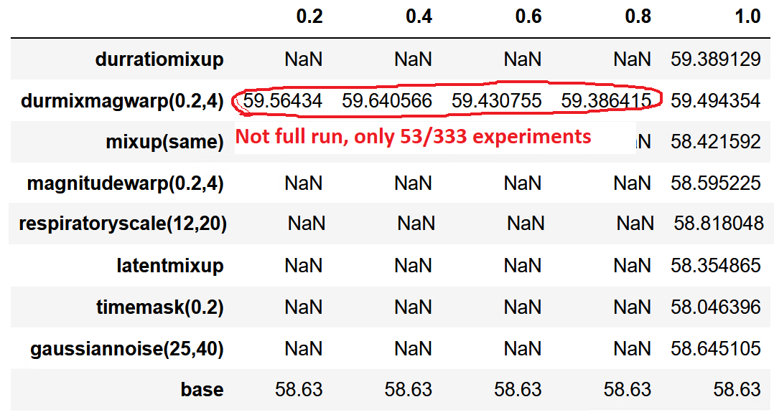

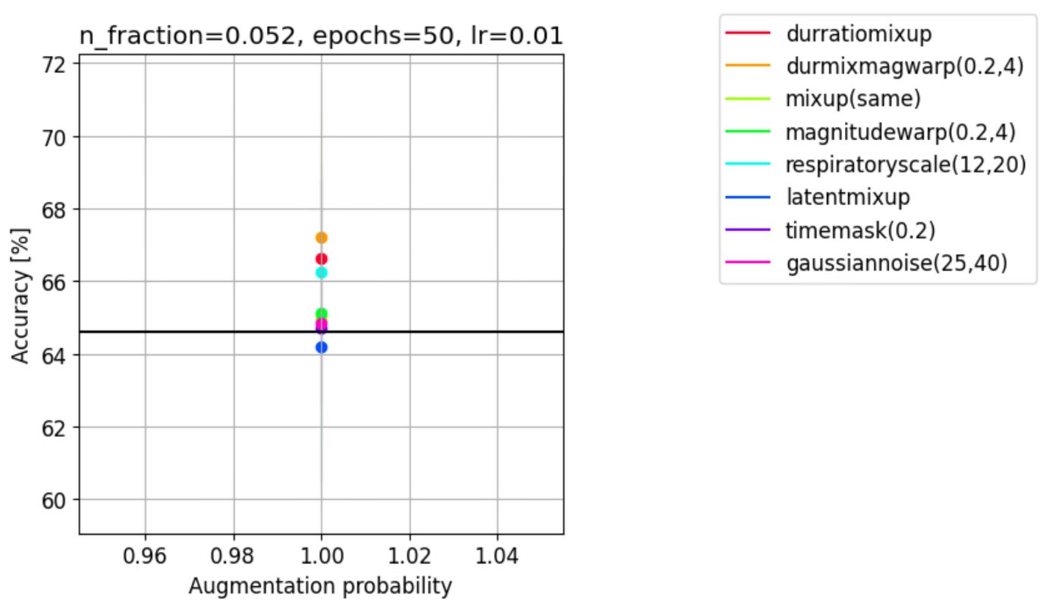

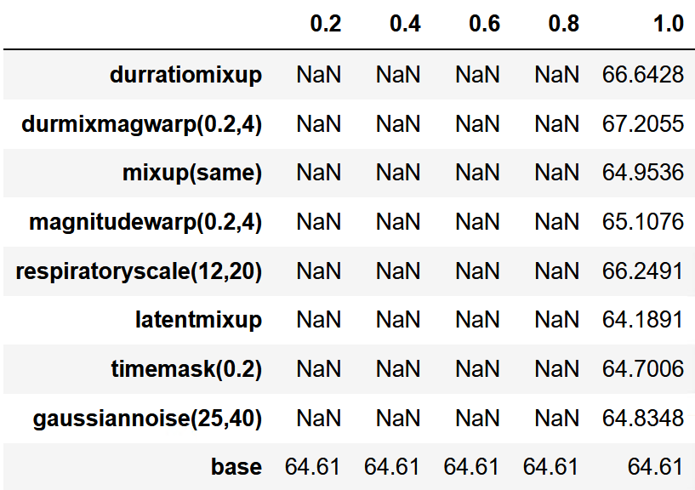

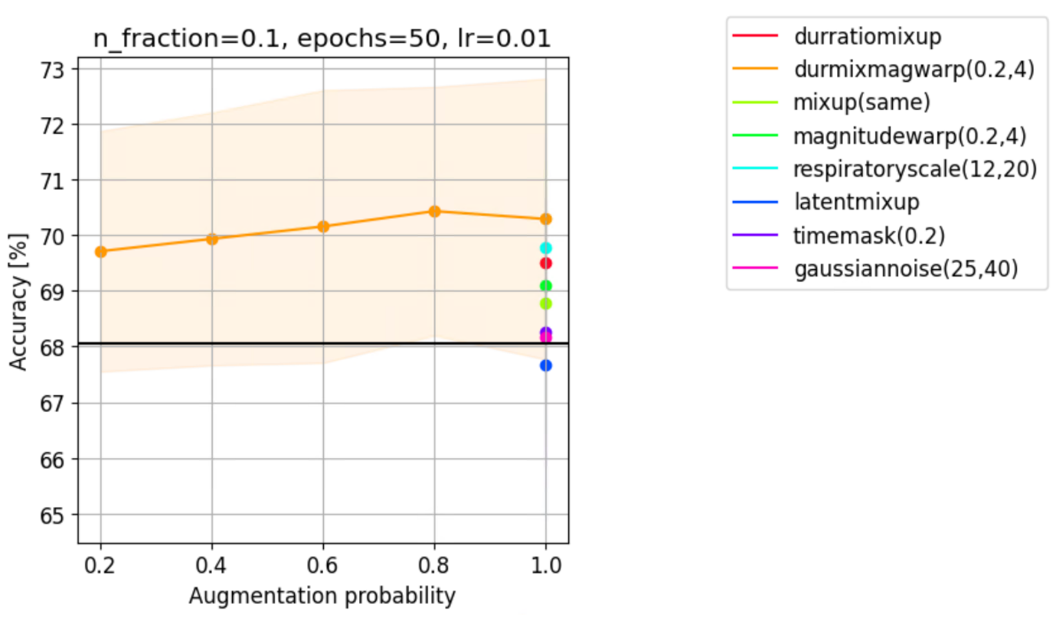

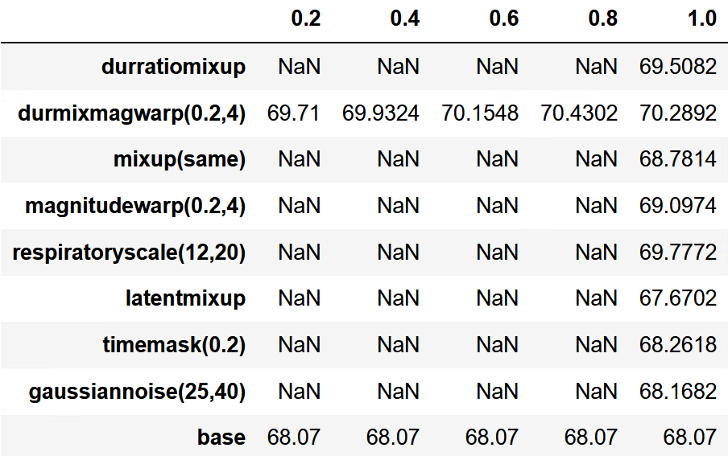

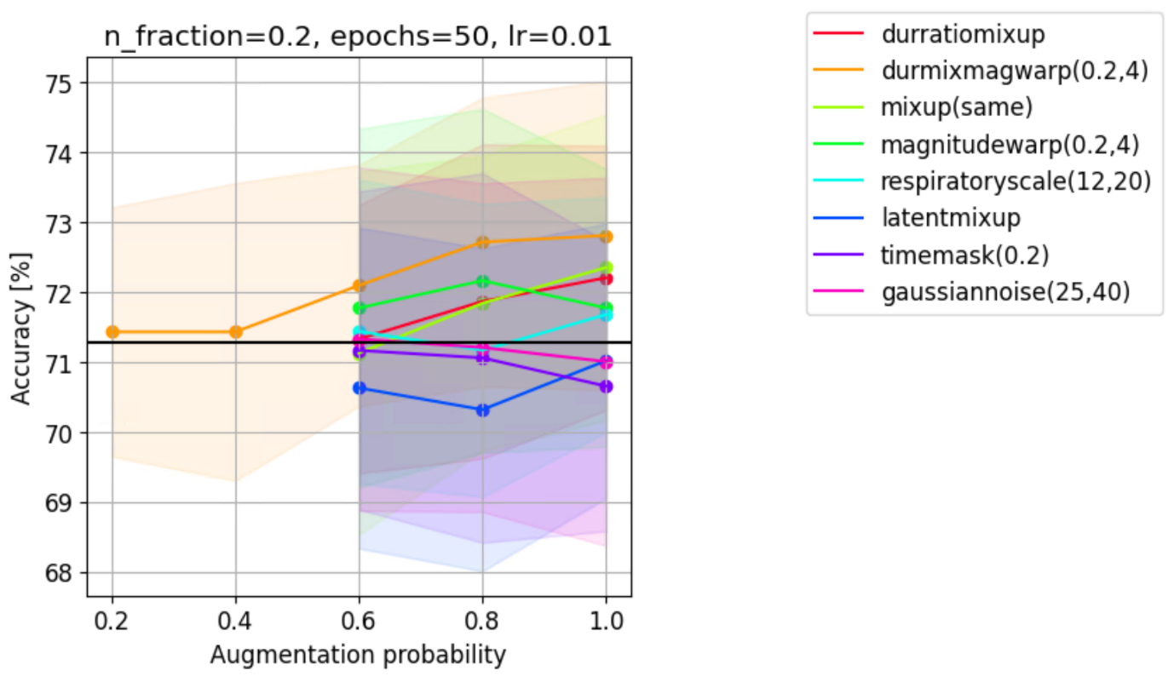

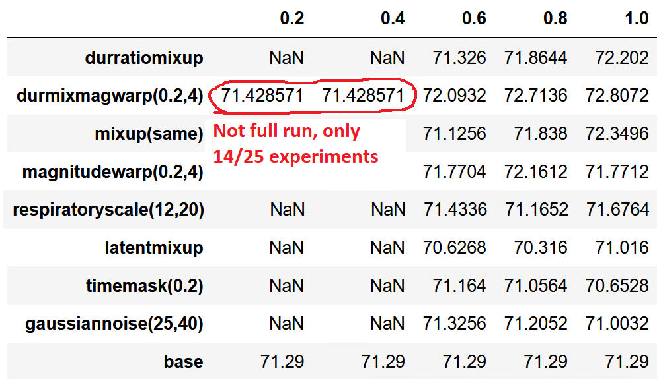

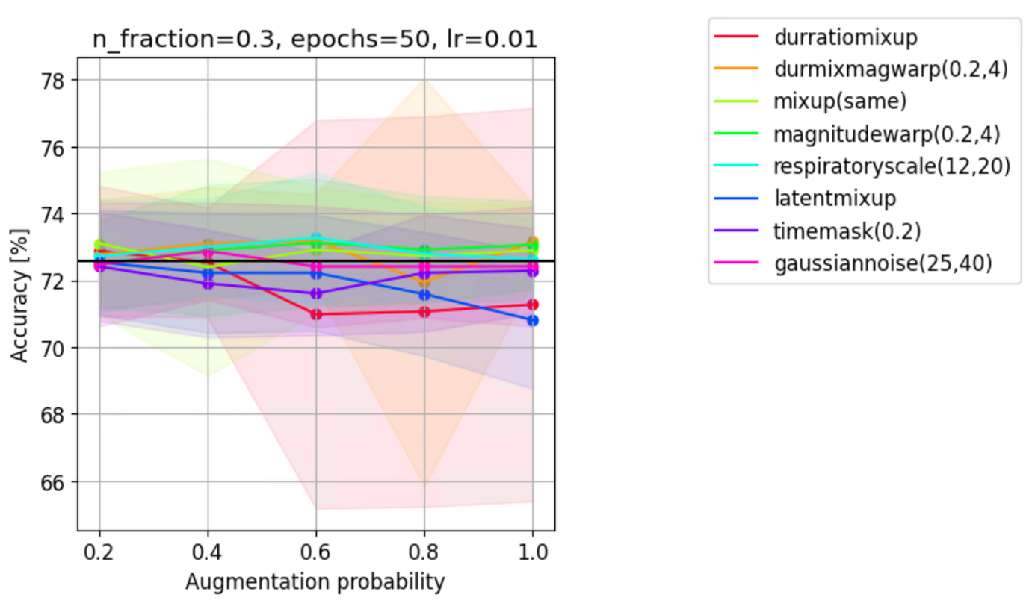

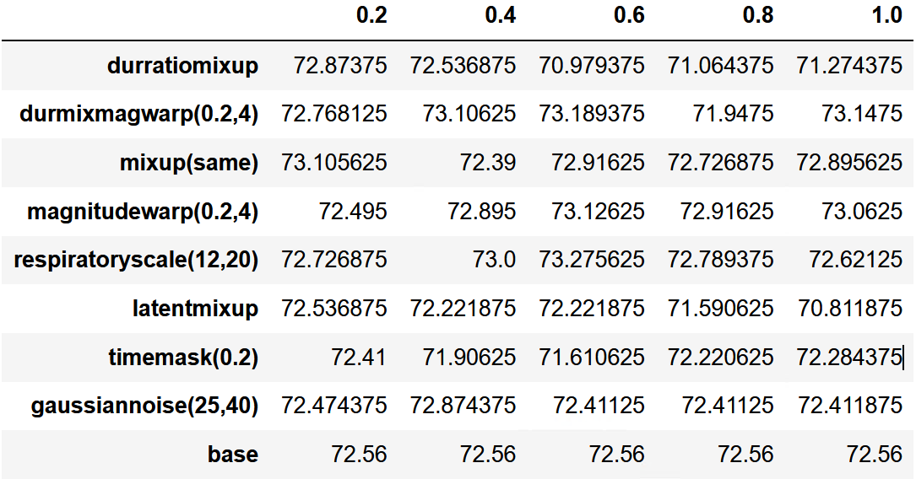

Average across aug_proba = (0.6, 0.8, 1.0)

* durmixmagwarp(0.2,4) = 72.761458
* Magnutudewarp(0.2,4) = 73.035
* Mixup = 72.84625
* Respiratoryscale(12,20)= 72.895416

->our method 4th due to unluckly outlier - keep in mind that still better than baseline (72.56) and best aug_proba=1.0 and second best at aug_proba=0.6

Default mode: aug_proba aways 1.0 -> our method, durmixmagwarp(0.2,4), always best

P-values between PCGmix+ and other methods

Potes final (selected) aug probas:

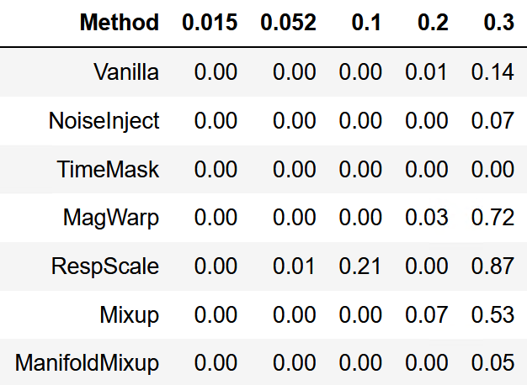

Potes default (always 1.0) aug probas:

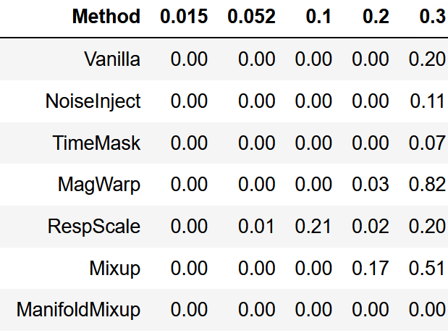

Resnet

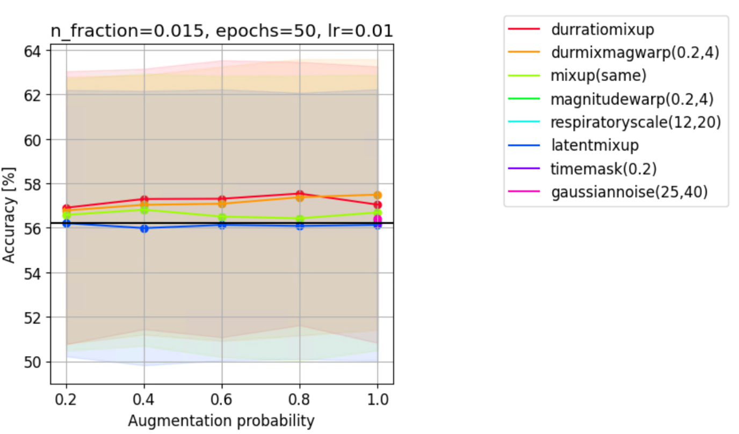

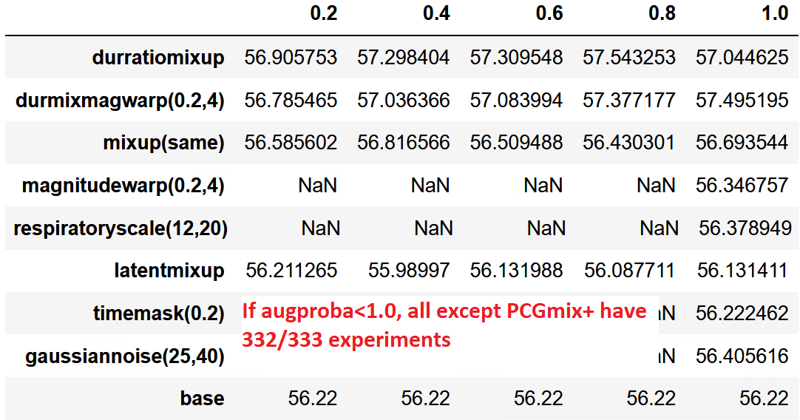

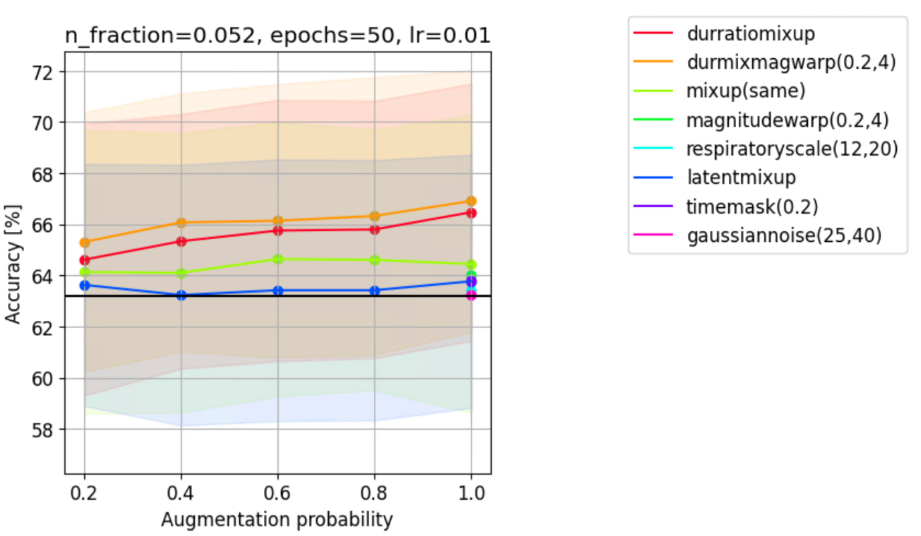

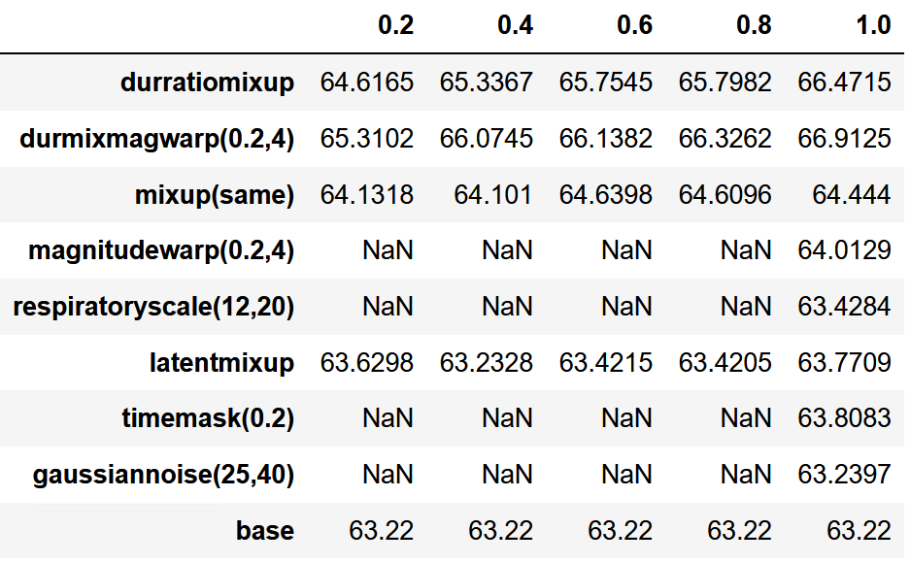

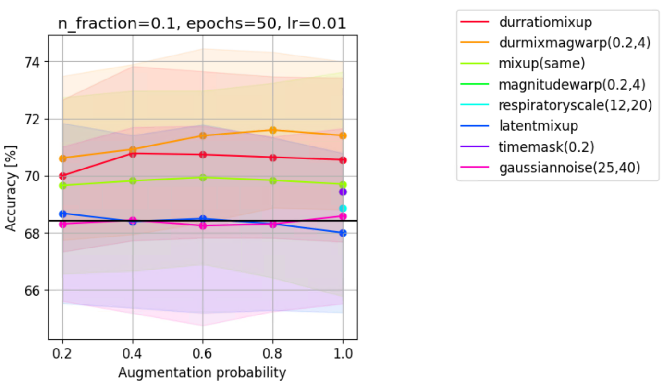

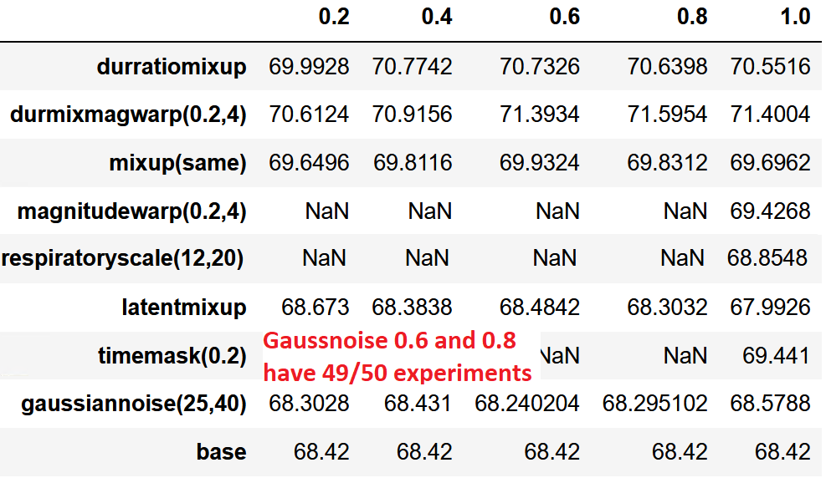

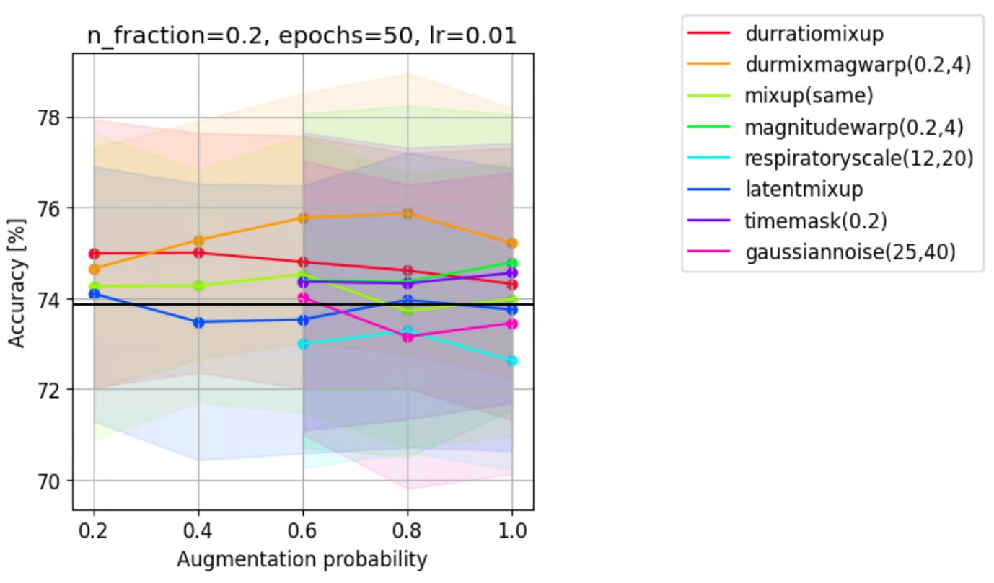

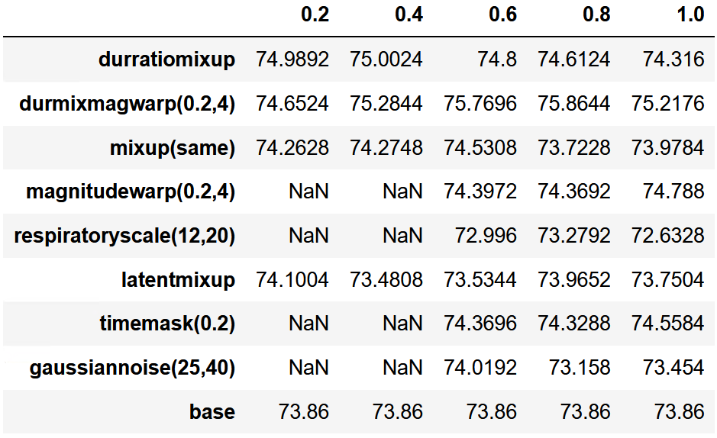

Aug_proba=1.0 is 0.65% acc worse than aug_proba=0.8

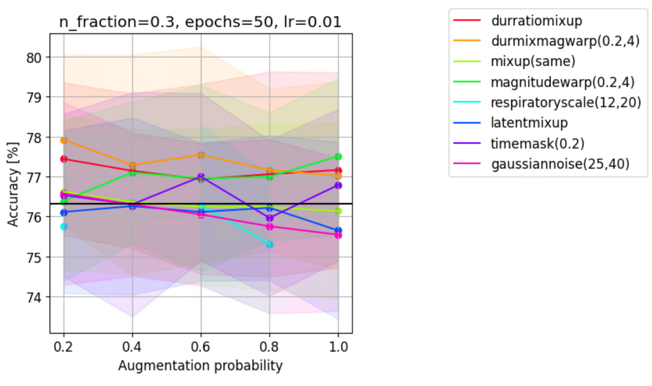

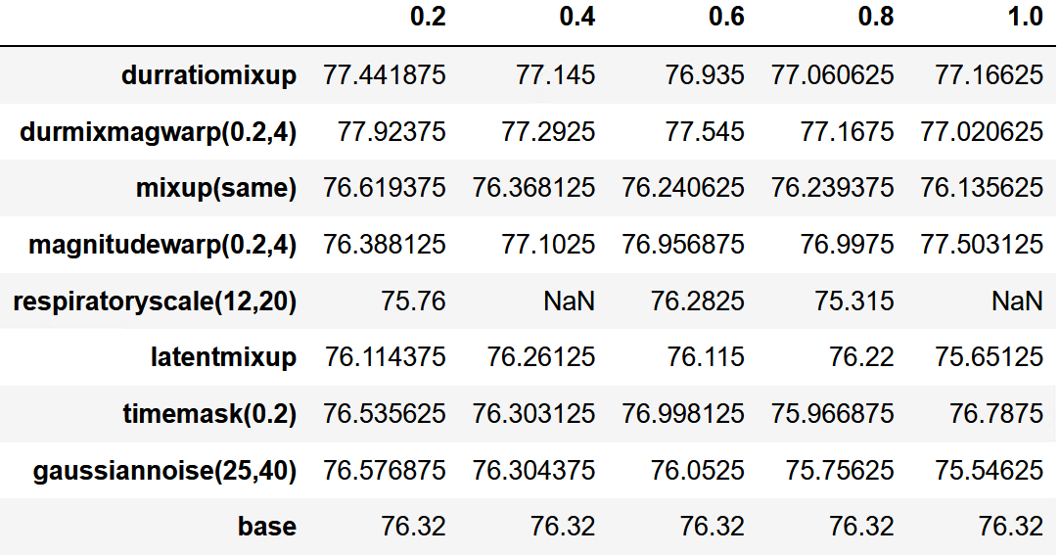

Average across aug_proba = (0.6, 0.8, 1.0) (note that at aug_proba=0.2, ours is »by far« the best overall:

* durmixmagwarp(0.2,4) = 77.244375
* Magnutudewarp(0.2,4) = 77.1525

->Ours wins

Default mode: aug_proba aways 1.0 -> our method, durmixmagwarp(0.2,4), always best, except nfrac=0.3 where it is 0.5% acc worse than magnitudewarp(0.2,4)

Resnet final aug probas:

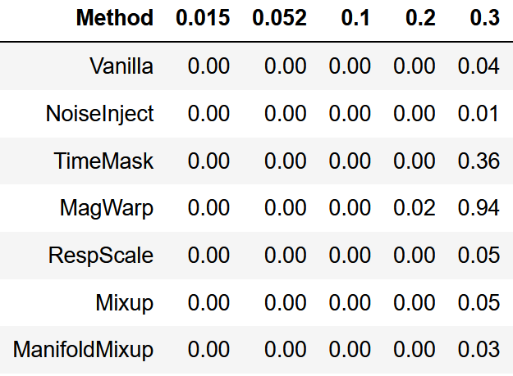

Resnet default (1.0) aug probas:

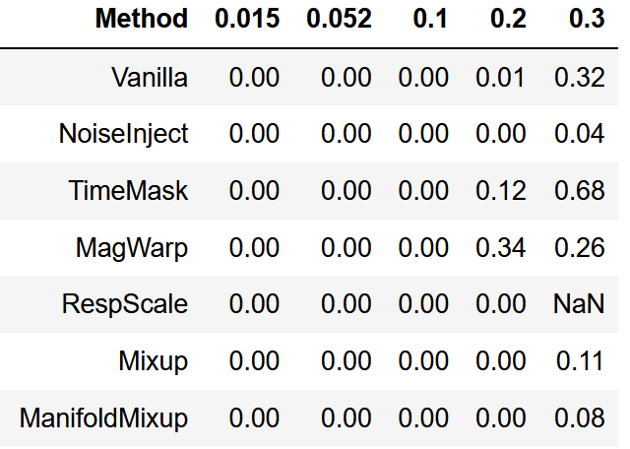

(note that for ResScape we didn't run experiments at aug_proba=1.0, but that method is worse than baseline)

VERDICT

Up until n_frac=0.3, our method is clearly by far the best at all times, no matter the aug_proba. At n_frac=0.3, our method still potentially the best, although we do not claim that anymore. It's most important that it's still much better than the baseline. At that point, it looks like magnitudewarp(0.2,4) is comparable to our method.

Statistical significance: again, up until n_frac=0.3, our method statistically significantly better than the baseline.

* For potes: using final (selected) or default aug_probas results in the same story up until n_frac=0.3 (RespScale at n_frac=0.1 and mixup at n_frac=0.2 have p-value above 0.05), whereas at 0.3 (where we dont claim superiority over other methods anyway) TimeMask's p-value gets ovr 0.05, whereas ManifoldMixup's deases from 0.05 to 0.00.
* For resnet: when using default aug_proba compared to final (selected), TimeMask and MagWarp get their p-values above 0.05 at n_frac=0.2, and at n_frac=0.3, baseline and ManifoldMixup p-values get above 0.05.

Detailed aug_proba analysis showed that our method is top for up to (including) n_frac=0.2. At n_frac=0.3, it's still great (although not as superior) and still always better than the baseline.